|  |
| --- |
| **Regression Table 1** |
|  |
|  | *Dependent variable:* |
|  |  |
|  | Lung Hospitalizations |
|  |  |
| Treatment Applied (1) | -14,856.100 |
|  | (48,672.250) |
|  |  |
| Year | 45.543*** |
|  | (16.383) |
|  |  |
| Treatment (1) x Year | 6.164 |
|  | (24.155) |
|  |  |
| Constant | 22,671.360 |
|  | (33,011.120) |
|  |  |
|  |  |
| Observations | 550 |
| R2 | 0.654 |
| Adjusted R2 | 0.652 |
| Residual Std. Error | 892.818 (df = 546) |
| F Statistic | 344.345*** (df = 3; 546) |
|  |  |
| *Note:* | *p<0.1; **p<0.05; ***p<0.01 |

**Notes**: This table contains a regression predicting lung hospitalizations as a function of whether Treatment is eventually applied (1 or 0) and Year for pre-treatment (2021) observations. The regression shows that there is a main effect of Year, such that with every 1 year increase, there is a 45.543 increase in lung hospitalizations (p < .01). The interaction between treatment and year pre-2021 is not significant, so we can say that the parallel trend requirement has been satisfied.

**DnD Line Graph**

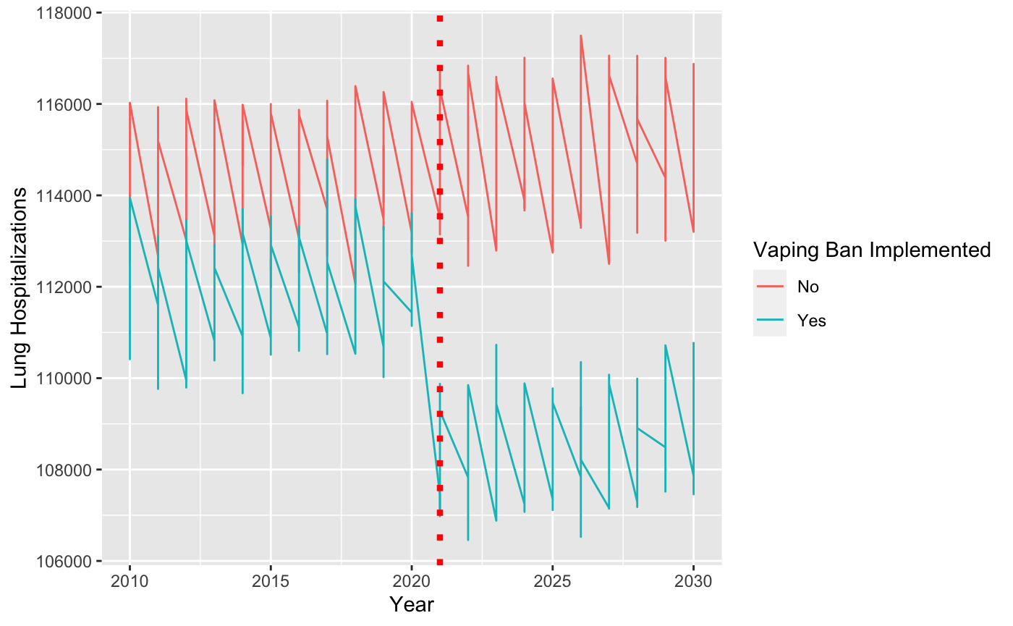

**Notes**: This graph shows that pre-treatment, the lines in non-treated (No Vaping Ban) and treated (Vaping Ban) places are similar (parallel line assumption is met). However, after the onset of treatment in 2021, the lines for treated and non-treated places change course. The line for treated places drops, demonstrating that the ban seems to decrease lung hospitalizations. Further testing is required to see if the results are significant.

|  |
| --- |
| **Regression Table 2** |
|  |
|  | *Dependent variable:* |
|  |  |
|  | Lung Hospitalizations |
|  |  |
| Post Treatment (1) | -36.886 |
|  | (71.673) |
|  |  |
| Treatment Applied (1) | -4,917.542*** |
|  | (165.457) |
|  |  |
| State 2 | -203.381 |
|  | (162.509) |
|  |  |
| State 3 | 229.333 |
|  | (162.509) |
|  |  |
| State 4 | 54.381 |
|  | (162.509) |
|  |  |
| State 5 | 483.810*** |
|  | (162.509) |
|  |  |
| State 6 | 411.667** |
|  | (162.509) |
|  |  |
| State 7 | 464.667*** |
|  | (162.509) |
|  |  |
| State 8 | 453.905*** |
|  | (162.509) |
|  |  |
| State 9 | 971.381*** |
|  | (162.509) |
|  |  |
| State 10 | 632.810*** |
|  | (162.509) |
|  |  |
| State 11 | 969.571*** |
|  | (162.509) |
|  |  |
| State 12 | 1,002.000*** |
|  | (162.509) |
|  |  |
| State 13 | 1,092.571*** |
|  | (162.509) |
|  |  |
| State 14 | 1,225.714*** |
|  | (162.509) |
|  |  |
| State 15 | 1,360.238*** |
|  | (162.509) |
|  |  |
| State 16 | 1,256.952*** |
|  | (162.509) |
|  |  |
| State 17 | 1,482.381*** |
|  | (162.509) |
|  |  |
| State 18 | 1,819.857*** |
|  | (162.509) |
|  |  |
| State 19 | 1,598.762*** |
|  | (162.509) |
|  |  |
| State 20 | 1,774.190*** |
|  | (162.509) |
|  |  |
| State 21 | 2,078.905*** |
|  | (162.509) |
|  |  |
| State 22 | 1,995.429*** |
|  | (162.509) |
|  |  |
| State 23 | 2,030.810*** |
|  | (162.509) |
|  |  |
| State 24 | -2,938.476*** |
|  | (162.509) |
|  |  |
| State 25 | -2,734.619*** |
|  | (162.509) |
|  |  |
| State 26 | -2,651.286*** |
|  | (162.509) |
|  |  |
| State 27 | -2,458.619*** |
|  | (162.509) |
|  |  |
| State 28 | -2,382.190*** |
|  | (162.509) |
|  |  |
| State 29 | -2,290.143*** |
|  | (162.509) |
|  |  |
| State 30 | -2,178.714*** |
|  | (162.509) |
|  |  |
| State 31 | -1,994.190*** |
|  | (162.509) |
|  |  |
| State 32 | -1,789.238*** |
|  | (162.509) |
|  |  |
| State 33 | -1,817.762*** |
|  | (162.509) |
|  |  |
| State 34 | -1,797.048*** |
|  | (162.509) |
|  |  |
| State 35 | -1,693.810*** |
|  | (162.509) |
|  |  |
| State 36 | -1,629.286*** |
|  | (162.509) |
|  |  |
| State 37 | -1,484.000*** |
|  | (162.509) |
|  |  |
| State 38 | -1,455.476*** |
|  | (162.509) |
|  |  |
| State 39 | -1,168.952*** |
|  | (162.509) |
|  |  |
| State 40 | -1,108.238*** |
|  | (162.509) |
|  |  |
| State 41 | -1,094.048*** |
|  | (162.509) |
|  |  |
| State 42 | -956.952*** |
|  | (162.509) |
|  |  |
| State 43 | -924.190*** |
|  | (162.509) |
|  |  |
| State 44 | -921.143*** |
|  | (162.509) |
|  |  |
| State 45 | -755.714*** |
|  | (162.509) |
|  |  |
| State 46 | -528.429*** |
|  | (162.509) |
|  |  |
| State 47 | -332.714** |
|  | (162.509) |
|  |  |
| State 48 | -292.905* |
|  | (162.509) |
|  |  |
| State 49 | -412.667** |
|  | (162.509) |
|  |  |
| State 50 |  |
|  |  |
|  |  |
| Year | 53.181*** |
|  | (5.368) |
|  |  |
| Post Treatment (1) x Treatment Applied (1) | -4,030.462*** |
|  | (65.287) |
|  |  |
| Constant | 8,754.906 |
|  | (10,816.170) |
|  |  |
|  |  |
| Observations | 1,050 |
| R2 | 0.962 |
| Adjusted R2 | 0.960 |
| Residual Std. Error | 526.591 (df = 997) |
| F Statistic | 491.263*** (df = 52; 997) |
|  |  |
| *Note:* | *p<0.1; **p<0.05; ***p<0.01 |

**Notes**: This table contains a regression to estimate the treatment effect of the laws. The model also contains time period fixed effects as well as state fixed effects. Results show that there is a significant decrease (beta = -4030.46, p < .001) in lung hospitalizations in treated states after the implementation of vaping laws in 2021. There is a main effect of Treatment, such that places that implemented the ban overall (across pre- and post-) had approximately -4,917 fewer hospitalizations (p < .01). There is also a main effect of the control variable (time fixed effect) Year, such that with every 1-year increase, there is a 53.181 increase in lung hospitalizations (p < .01).

Questions:  
**1. How many state-level fixed effects are there?**

There are 48 state level fixed effects in the Regression output. That is because State.id = 1 is being used as the reference category, and State.id = 50 runs into a collinearity problem, thus outputting NA.

**2. What is the interpretation of the coefficient for each state-level fixed effect?**

Each state-level fixed effect in the regression output shows whether the given state differs significantly from the reference category, State.id = 1. All states differ from the reference category except State 2, State 3, State 4, State 48, and State 50 (given that it faces a collinearity problem).

**3. Can you reject the hypothesis that state fixed effects are all zero?**

I ran an additional test to determine if the coefficients associated with the state fixed effects are equal to zero. The regTermTest function from the “survey” package outputted a significant p-value, meaning we can reject the null hypothesis that the coefficients are all equal (zero). See output below:

Working (Rao-Scott+F) LRT for State.Id in lm(formula = Lung.Hospitalizations ~ post + treatment + post * treatment + State.Id + Year, data = data)

Working 2logLR = 587991990 p= < 2.22e-16

(scale factors: 1 1 1 1 1 1 1 1 1 1 1 1 1 1 1 1 1 1 1 1 1 1 1 1 1 1 1 1 1 1 1 1 1 1 1 1 1 1 1 1 1 1 1 1 1 1 1 1 ); denominator df= 997

**Notes**: I used use lrt.approximation="satterthwaite" to match other software (like Stata).